REFLECTIONS AND OBSERVATIONS – 2018 ANNUAL REPORT

Things are in a state of change – that much seems clear. To what, and why, are not so clear.
But this is not an unfamiliar state for us - AfrikaBurn is designed to provoke change. We’re asked to disrupt the comfortable, to galvanise, to invite and embrace the experiment and be open to the unpredictable.

And the truth is, perhaps, that we got a bit too comfortable. So, when 2017 rolled around and bit us on the ass, it got real pretty quick. Coming out of ‘Play’, the criticisms were clear : POOP, SOOP, MOOP, Plug and Play camps, “the festival crowd” and service-mentality, the Clan that almost wasn’t, so much heat and so little ice, and the terminal dangers of the R355 … the community was clear about where they stood on these issues, and the team worked hard to address them with a number of key interventions.

Key interventions to course-correct

The Big Switcheroo in 2018 saw Tankwa Town’s layout reinvented, with our urban planning team moving sound camps to one side of the Binnekring and freeing up more space for quieter camping. The introduction of mandatory shutdown times brought pause and peace to the community in the mornings. Both these initiatives were well-received and will roll out again in 2019.

The new toilet design, commissioned by a local sanitation expert, centered around reducing environmental impact while improving the standard of sanitation. The new loos are constructed primarily from recycled and/or recyclable material and make use of environmentally-friendly chemicals to facilitate a closing of the cycle with the eventual generation of humanure.
Although not everybody loved the new design, and despite the teething problems with on-site servicing, the overwhelming feedback has been positive.

The R355 safety campaign and the associated investment into official provincial road signage (working with both Western and Northern Cape Govt) was largely successful and saw both a significant reduction in incidents and an increase of our community’s sense of personal safety. From responses in the 2018 Survey we can infer that around 50% of people drove at or below our recommended speed limit of 70km/h. We’re looking forward to an even better campaign in 2019 that will see an increased amount of assistance from Northern Cape and Western Cape regulatory bodies.

The community responded well to the introduction of vehicle passes. The 3500-odd issued served not only to reduce pressure on the R355, but also to reduce congestion in the camping areas by reducing the number of vehicles on site. Vehicle Passes were gifted to creative contributors, in acknowledgement of their efforts and so as not to increase their costs, and this will continue in 2019.

Airspace was reframed with a focus on providing a viable alternative means of travel to Tankwa Town and saw an increased percentage of participants choosing to travel this way.

Our Supplier Process was overhauled and tightened up, in an effort to better align supplier activity with AfrikaBurn’s ethos. The Supplier Support charge was introduced to help cover the costs associated with the management of supplier activity on site, going towards costs associated with staffing and infrastructure for the Supplier Process, the Supplier Gate and the Supplier Depot. This proved quite contentious (primarily with suppliers) and so the decision was made to defer roll out of the Supplier Support charge to the 2019 cycle.

The community
After years of heady steady growth, curtailed only by a self-imposed cap on numbers, things changed abruptly.

The effect of the drought on the economy and tourism proved a significant curveball.
As Cape Town drew closer to Day Zero, concerns grew amongst the international community about the prospect. But Burners have been in training for “the new normal” since Larry Harvey and his crew first kicked up the dust out in Black Rock City. The Burn teaches you how little you really need, and we can feel proud of the modest impact the Burn had on reducing Cape Town’s water usage, and teaching humans resilience, over the period.

The pressures exerted by the water shortage, and rising consumer costs in the face of economic uncertainty, were likely a contributing factor to the slower ticket sales. But perhaps not the only one.

A number of long-standing creative Collectives decided to take the year off…simultaneously. The result was a quieter, more intimate burn, with smaller pockets of activity and a greater diversity of expression, which was deeply appreciated, even as the big sound was missed. The challenge will be to keep this balance going forward, making sure there is room for all, and that all have their moment to shine.

We seem to have found our best fit in 2018, with things settled at a more comfortable level.
But damn that was interesting! Our team was genuinely worried about the future of AfrikaBurn – but by using our experience and listening to our community, we did what we could to ensure we headed in a more sustainable direction.

Belt-tightening, budget cuts and frugal panties
The team scaled back across the board and invigorated efforts at keeping costs to a minimum, leveraging human effort, rather than expedience, to support the staging of AfrikaBurn on reduced ticket numbers.

Outreach activity was also impacted and was scaled back to ensure our core commitments in the Tankwa could be supported. Much of the committee’s work for this year has been internal foundational work, defining objectives and processes, to support a more structured and pro-active approach to the work. (See Outreach report for an overview of activity).

The stats
The benefit of planning for a larger capacity meant the team had breathing room, and the infrastructure and resources felt less strained than was the case in 2017.

The population
Just over 11 000 tickets sold, and just shy of 10 000 people came through the gate, bringing the population of Tankwa Town to around 10 500 in 2018.

Roughly 75% of Tankwa Town’s population is South African (just under 70% of us come from the Western Cape, 16% of us from Gauteng, and just under 15% from elsewhere in the country), with the rest international participants. Of the internationals, notable presence came from Germany, the US, the UK, the Netherlands, France, Israel, Reunion, Kenya, and Spain.

The age range of participants remains wide – from infants to octogenarians.

Burner Bio data indicates something unprecedented and really interesting … a shift in the ratio of Veterans to First Timers. I’m wary to hazard a guess as to whether this was an anomaly or will continue in the future, but it certainly bears considering. Culture is a living, breathing, evolving thing and it stands to reason that a community in development will shift and change. New adopters speaks to continued relevance and long life, which is hugely positive. On the flipside, the loss of long-standing creative collectives and custodians of our culture represents a potential risk to AfrikaBurn’s sustainability. However, bearing in mind that many longstanding Collectives took 2018 off and are planning to return in 2019, this also speaks to a natural succession, and again resilience: after all, not everyone can come every year, and especially if they’re involved in large projects, which many of our veterans are.

The creative landscape
Once again the creative community brought their magic to Tankwa Town, with over 100 artworks, 12 official burns, 26 performance projects, 92 theme camps and 76 mutant vehicles activating the landscape.

Approximately 24% of the event operating budget (or roughly 10% of the annual budget) was allocated to creative projects, including Creative and Mutant Vehicle Grants, the fledgling Tech Grant fund, the Clan effigy and the Temple space.

Within this mix was Lakes of Fire exchange beneficiary, Rocket. Saarah Fletcher, long-time DMV member, was selected as the AfrikaBurn exchange beneficiary for this exchange program, now in it’s 5th year, taking the Mini-kring to the Midwest USA’s regional burn.

Music is a huge part of the creative landscape in Tankwa Town, and Radio Free Tankwa is an integral part of this. Results from the annual Survey are encouraging – according to those, 44% of people at AfrikaBurn 2018 listened to the station (in their camp, cars, at Ice, at RFT itself or on mutant vehicles). This is an excellent indicator of the growth of listenership – and the team itself continues to grow, with new volunteers coming aboard, including a qualified sound engineer – but they could really use the help of another FM radio engineer. Know anyone?

Volunteer community
The volunteer community continues to step up, and nowhere more clearly than at the AfrikaBurn event, where around 1100 volunteers filled in excess of 3250 shifts. A whopping 70% of volunteers signed up before we got to site and No Shows were few and far between.

The challenge lies in translating this outside of Tankwa Town, to build on the solid core of volunteers who support the project at Volunteer Workdays, and Decompression and Streetopia. And to drive recruitment of volunteers into the portfolio wrangler teams, to build capacity to support the work year-round, and to support routes to succession.

Rangers are a key part of the Burn community’s volunteer social support structure, and two years in the Ranger Crew program is having a measurable impact on building this core. The Ranger Crew program is open to experienced crew committed to working a minimum of thirty hours, including a night-time shift on either the Friday or Saturday of the event. For this commitment, a Ranger joining Crew is invited to live at Ranger accommodation and eat in the AfrikaBurn Mess. In total there were 58 international Rangers and 12 local Rangers on Crew, and between them they filled the bulk of Senior Ranger shifts on site this year, helping spread the load across more shoulders.

Rangers logged 4497 hours of shifts at Working Title, including 432 hours of Green Dot work and 984 hours on Fire Perimeter.

Sanctuary and the Community Health Cluster are another key part of the community support plan. Over the week of the event 73 volunteers served a total of 1036 hours providing support and assistance to 175 guests.

DPW Hammer Council and Kitchen core spent almost 70 days on site through the whole event path. Far longer than ever before, and far longer than planned, but an unavoidable consequence of factors outside of our control, including challenges with service provision and environmental challenges.

Airspace and the volunteer team that serve it supported 191 aircraft movements, including 6 helicopters, moving a total of 1040 people into or out of Tankwa Town, 70 people on scenic flights, and 4 emergency med-evacs by air. Their work also facilitated creative play in the recreational zone, which included 64 parachute drops and 14 paraglides

Our heartfelt thanks go out to all who helped make and hold Tankwa Town this year.

With special mention to those who have stepped out of operational roles in the past 18 months or so, making way for fresh energy and new perspectives:
Julia Savage, stepping away from the Operations Manager role but remaining in place as Gate and Ticketing lead.
Liz Linsell and Jacqui Woolfson after close on a decade leading the Volunteer portfolio.
Helena Sheridan, after 5 years in DPW leadership, and Paul Grose who has held a leadership role since year one – although both remain committed to serving the portfolio in an advisory capacity.
Erica Inches (DMV administrator), Michele Smith (Operations Coordinator), Sheriff Du Plessis (Nansen St Yard Custodian), Sisanda Booi (Finance intern).
Captain Tom (Airspace) has hung up his flight suit after 9 years of keeping Tankwa Town International and the blue skies above it a safe space for play. Tom remains committed to providing support to the new Airspace leadership team and is looking forward to engaging in other areas of the work AfrikaBurn does.
We also say goodbye and thank you to outgoing Ranger Council : Ranger Thermo (Council Chair), Bumblebee (Green Dot), Flooze, Stilleto, Kali, Chrigi (and Ranger Bob – Jono Hoffenberg – before them), and are hugely grateful that each offers continued support and service to the AfrikaBurn community in some capacity.

* please forgive me if I’ve missed you … the list is long, the team is large, and I am fallible … you are appreciated, believe me.

Home is where the heart is
AfrikaBurn HQs new home at The Junction Hotel in Salt River affords plenty of space for creative collaboration, volunteer activity, trainings and skills-development opportunities. It’s been a hive of activity in the run up to the event this year and the space has been energised with multiple activities happening simultaneously. The space makes possible the development of an extended annual program of activity and we will work to roll this out in the coming cycle.

Land: a new blank canvas
The question of Tankwa Town’s home remains unanswered at this moment – but not for much longer. AfrikaBurn’s land committee has continued investigating the prospect of purchasing land, identifying two viable parcels that are available, and continued exploring potential land usage models that support more than just security of tenure and agency on the property – including ongoing research into biodiversity corridors, earth jurisprudence, community support, and potential interventions that recognize and address the history of land dispossession in South Africa.
It presents a considerable challenge, but we are working through it diligently and with careful consideration.

Decompression
Decompression 2017 set the bar high for participation and electrified those of us who made it out on that very wet night. Decompression 2018 delivered on that promise again and provided the community with a much-appreciated opportunity to reconnect with the tribe and reconnect with the gees. DPW returned to the city that same weekend – many of them directly to Decompression, where they were met with a hero’s welcome.

Streetopia and the Streetopia Legacy Project
Streetopia, our urban hybrid version of the Tanwka experiment, is maturing nicely with meaningful participation from the local, and non-burn community gaining ever-increasing traction. It enjoys support from the City of Cape Town, The Observatory Civic Association (OCA) and OBSID. The event is building a solid reputation, off the back of which the support provided by the businesses in the activated stretch of Lower Main Road is growing to match the participation levels by creative contributors and volunteers - some 50 volunteers were involved over two days helping with signage, setup, rangering, mooping and strike.

The Streetopia Legacy Project grew out of the hypothesis of art as an intervention, with the aim of vitalising the space and improving the way the community interacts with it. It brings creative interventions into the urban environment, leaving permanent installations in place.

Planning for Streetopia 2018 is already underway, with the daytime community festival set to take place on Saturday 1 December. 2018 saw Streetopia get a complete refresh on the design front. The event’s schedule of communications has been rolling since the 2018 event was announced in August, and includes streetpole posters for the first time. The response to this year’s event has been excellent and has been supported by a wider range of social media channels, with an Instagram and Twitter account added to the spread, both of which are doing well.
We’ve received funding and in-kind support for aspects of the event production and some infrastructure investments, as well as funding for Streetopia Legacy Projects.
Please join us – it’s going to be a goodie.
Plans to co-fund and manage similar legacy projects with the newly revived AHSCOM are underway, and exploratory discussions have begun with Jozi Burners Creative Projects around a potential Streetopia Joburg for 2019.

Blank Canvas Express
With a million Rand in external funding support secured for ABCPs development projects, we have finally been able to launch the Blank Canvas Express – reaching out to communities in the Northern Cape that would not ordinarily have access to information about AfrikaBurn, and catalysing community engagement in the way we do best - activating collaborative art processes, partnering local creatives with AfrikaBurn creative contributors.

This 5-phase initiative supports arts development in the region and improves our reach into and impact on these communities, with the intended aim of generating greater diversity of participation at AfrikaBurn. (See Development report for an overview of activity).

With AfrikaBurn’s 2017 and 2018 surveys now completed and the data crunched, we are some way closer to being able to complete an Economic impact assessment for the Western Cape Government which will help frame and quantify the economic value AfrikaBurn brings to the Western (and Northern) Cape, and which could support unlocking funding for the annual event. This becomes increasingly important in light of South Africa’s economic climate – besieged by rampant fuel tax hikes, rising food prices, and the impact of water scarcity, many in our community are feeling the pinch.

2019 event budget and concerns, ticket numbers, ticket cost … we don’t really know what the new normal is …

The simple fact is that the AfrikaBurn ticket price generates the income that drives year-round operations, funds all Outreach programs and Development initiatives, and covers the lion’s share of operating costs and staff costs for 2 other events (Decompression and Streetopia – with Decom bringing in a modest amount of additional revenue from ticket sales, and Streetopia bringing in a small contribution from neighbourhood businesses and stalls).

The point of tension lies between balancing the drive to build the community with recognition of individual constraints, between an inclusive community and an exclusive community. The event production costs are exacerbated by the remote location, as are the costs outside of the ticket price for participants. But the remote location, the distance from the default world, are key to unlocking the transformative impact of time spent in Tankwa Town.

While the survey results infer that many people are fine with the ticket price, feedback on social media indicates that others find it uncomfortable and are concerned about rising costs - and that not all who buy a ticket to AfrikaBurn understand (or buy into the idea) that by doing so they are supporting a broader movement focused on community-building, social responsibility and arts development.

Ticket stats for 2018, and early sales data for 2019, bear careful consideration as we find the way forward in terms of ticket price.
Interest in AfrikaBurn remains high, and our Comms team have invested time and effort guiding the framing of our experiment and encouraging coverage that goes deeper than the usual “party in the desert” angle, and curtailing businesses, culture pirates, and influencers attempting to leverage AfrikaBurn to further their commercial aims.

But changes to Facebook’s algorithm have had a significant impact on our reach and we are no longer able to attain the level of visibility with AfrikaBurn’s main page that it had last year.
To overcome this barrier, and instead of simply paying Facebook to boost posts, high-level content is now also shared out to community-run spaces. The high level of engagement now seen on the AfrikaBurn Group means all top-level announcements have good visibility and reach.

Top topics this cycle included toilets (34 000 people reached), ticket pricing (26 000 people reached), and the 2019 event page (close on 205 000 people reached by 15th October, just two weeks after its launch). And props to Simon Faragher and Chris Piotrowicz, whose AfrikaBurn after-movies together reached 90 000 people.

The way people access information on AfrikaBurn changed significantly in the 2018 cycle, with over 50% going through the website, the newsletter and the AfrikaBurn community-led Facebook group, in near equal proportion. While the website enjoys 1.5 million pageviews a year, we have seen a significant drop in new users. Coupled with a dramatic increase in “active users”, this indicates that although our community is condensing, they are more engaged and participatory online.

Our Tribe system – the online platform servicing our community - is growing exponentially, enjoying a dramatic increase in usage and engagement. Ultimately the best statistic is “user retention”, which shows that 9000 users stayed engaged over a 28 day period, while the same statistic last year was just 10% of that total.
We’ve had 12 934 new users register a Burner Bio in the past 12 months, of which 3 641 have registered since the 2018 event.
Collectives are a hive of activity with 227 active, registered and updated since the 2019 iteration of Tribe (launched 15 August 2018).

Over 42 000 people have subscribed to the AfrikaBurn newsletter, growing by 18% this cycle, and portfolio-specific newsletters (Rangers, Theme Camps, Volunteers and Creative) have also launched this cycle and enjoy impressive open rates.

We’ve built a lot of Instagram love in this past year and a half. When we launched it, just prior to the 2017 event, we had a couple of hundred fans, and an average reach per post of about 1 000. This page has blossomed, now reaching between 5 000 - 6 000 per post, across a fan base of 6 500 .

In stark contrast to the 2018 event cycle, where we experienced significant flak, and negative feedback from our community, as well as a host of flame wars in the Group, this year the community was more reflective and appreciative. The 10 top conversation topics were:
- In depth conversations about the experience, the art and the creativity.
Appreciation, introspection, and gratitude.
- Conversations about the skies and moon.
- Appreciation for Prometheus.
- Skydiving and views from above.
- Decompression and the shock of re-entering society after the event.
- Appreciation for the Clan.
- Who dared decide on plastic armbands?
- Discussion around the Ephemeropolis theme.
- Appreciation for the MEIDMAR Treasure Chest.
- And the consent discussion sparked by the launch of the Consent Free Zone.

To sum it all up, the community is changing. We have less tourists, less sparkleponies, and more engaged participants. People who want to get involved. People who are teaching others. A more solid community. Quality over quantity.

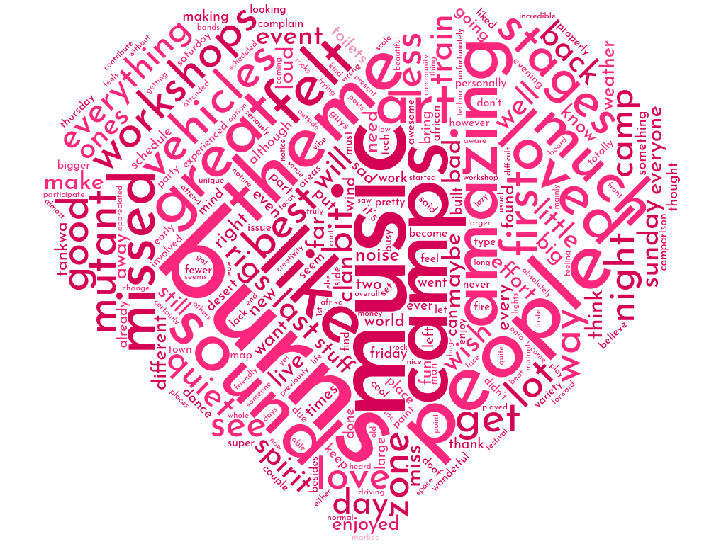

And there you have it.

Nothing about AfrikaBurn is designed to be easy, and the discussions and decisions that lie ahead of the organisation will not be simple or easy to navigate as we find our way. But it is necessary work, the kind that nudges up against head and heart and values and asks you to find a way that balances all of this and more. And for a community such as ours, this is the kind of work that really matters.

Thank you for being part of this experiment!

