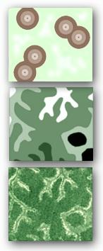
Dr. Philip G. Desmet
84 Clearwater Road
Lynnwood Glen, 0081
tel: +27 012 348-0577
mobile: 082 850 8751
email: DrPhil@ecosolgis.com
VAT No. 4400284156
Tax No. 2759150143
SA ID: 7003145146087
Pr.Sci.Nat. 115310

5th August 2019
Observations on the Botanical Significance of the Farms Quaggafontein, Vaalfontein and Klein Papekuil in the Tankwa Karoo.
DRAFT 1
This report summarizes my preliminary observations on the botanical significance of two potential Burn sites visited on the 29th of July 2019. This report is an opinion based on what was observed at each site and does not constitute a full specialist study that may be required for any development application.

Quaggafontein and Vaalfontein
These two properties are located in the Western Cape Province adjoining the southern border of the Tankwa National Park. The central and northern portions of these farms comprise the northward-draining sheet wash plains flowing from the Skoorsteenberge that form the southern border of the properties. There is a perennial sweet-water spring on Quaggafontein located on the plains between the mountains and Kwaggaskop. This farm is also located on a historic “trekpad”. There are currently no livestock on the properties, however, there are healthy populations of game present with numerous gemsbok, red hartebeest, springbok, zebra and ostrich observed.
The vegetation of the sheet wash plains can be classified as Tankwa Karoo (SKv5) dominated by the shrubs Salsola aphylla (gannabas, asbos or seepbos) and Galenia africana (kraalbos) on loamy soils, and the grass Stipagrosis ciliata (Langbeen boesmangras) on sandy soils. Several bulb species were observed throughout the plains with a high density inferred at the proposed burn site (orange circle in Figure 2) due to the high density of rodent digging. Most notable at this site is the abundance of Haemanthus tristis (Figure 1). This species is endemic to the southern Tankwa Karoo and is classified as a threatened species (Vulnerable D1) and is a species of conservation concern.
The ecological condition of the plains can be categorized as extremely degraded as there is exceptionally low diversity of perennial shrubs. Large areas, especially the slopes of Kwaggaskop, comprise almost exclusively kraalbos. This is an unpalatable indigenous increaser species characteristic of old ploughed fields or over grazed situations. Palatable plants species, gannabos and boesmangras, on the plains show signs of very heavy current grazing. There are also extensive desert pavement areas that appear to have been created from recent erosion rather than being natural features. The presence of a perennial spring and being located on a trekpad suggest that the current degradation is the result of historic rather than current land-use.
The vegetation of the hills on the southern border of the properties is Koedoesberge-Moordenaars Karoo (SKv6). This area was not investigated in detail. The higher diversity and density of shrubs on the rocky foot-slopes of the mountains suggest that the veld here is in a better ecological condition. This is consistent with the general observation throughout the karoo that mountain veld tends to be more resilient to degradation.
The majority of the farm area is classified as Other Natural Area by the Western Cape conservation plan (Figure 2). Only the drainage lines are classified as Ecological support Area or Critical Biodiversity Area 1, in the case of the larger washes. Therefore, a certain level of development would technically be allowable on the plains, however, this site is adjacent to a national park which may trigger the need for environmental approvals in terms of Listing Notice 3.

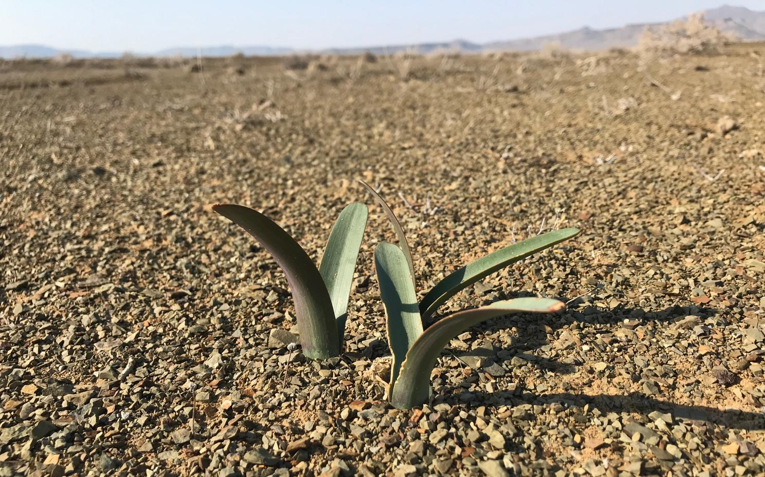
Figure 1. Haemanthus tristis is a species of conservation concern growing on the plains around “Benny Hill” (orange circle in Figure 2). This species was observed at several locations on the plains at Quaggafontein and Vaalfontein. This southern Tankwa Karoo endemic is classified as a threatened species (Vulnerable D1).

Klein Papekuil
This property is located in the Northern Cape Province in the ecological corridor linking the Tankwa National Park to the Greater Cederberg conservation complex. The vegetation of the site is Tankwa karoo (SKv5) and that of the drainage lines that run through the site Tanqua Wash Riviere (AZi7). The plains are mostly rocky desert pavements with very sparse vegetation characteristic of the central Tankwa Karoo. No livestock are currently present on the property and the veld indicates that there have not been for some time. Despite the extreme arid situation and lack of vegetation, the healthy condition of shrubs and grasses; the high density of burrowing animal activity; and, presence of active termitaria suggest that the veld is in a good ecological condition. No plant species of conservation concern were observed at this site.
The whole site is classified as Critical Biodiversity Area 2 in the Northern Cape conservation plan (Figure 3). This is because it is located in the ecological corridor linking the Tankwa NP with the Cederberg rather than there being a presence of species or habitats of conservation concern. Any listed development activity within this site will technically require approval from the authorities.
Recommendations
- Of the 2 sites assessed, Quaggafontein and Vaalfontein are a better choice for the location of the Burn. The plains are highly degraded; the “Benny Hill” site is not earmarked as a CBA; and, it is outside of the ecological corridor connecting the Tankwa NP with the Cederberg therefore limiting the overall potential negative impact of the Burn on environmental planning receptors.
- It should be noted that the “Benny Hill” site is a sheet wash plain therefore it can be expected for water to flow through the site periodically and widely across the plains in a network of drainage lines. These drainage lines are clearly observable on the ground and on aerial imagery and should be mapped together with a high resolution (e.g. 0.5m or better) digital terrain model (e.g. LIDAR) before any “town planning” or infrastructure is planned for the site. The advantage of the sheet wash plain is that water will drain rapidly from the site and there are no local depression that would hold water for an extended period of time.
- Quaggafontein and Vaalfontein are located in the Western Cape where environmental planning regulations are better regulated. It would be advisable to seek an opinion from an environmental practitioner, CapeNature or the department (DEA&DP) as to what the authorization requirements for the Burn activities may be. Although not located in a Critical biodiversity Area, “Benny Hill” is none the less within a protected area buffer therefore other land use and development restrictions may apply.
- As the “Benny Hill” site is adjacent to the Tankwa National Park it would be neighborly to conduct a visual assessment of temporary and especially permanent infrastructure of The Burn on the sense of place and “wilderness feel” from the perspective of the national park. The natural landscape visual aesthetic is an important and valuable commodity of the park Understanding this impact and developing strategies to reduce/avoid/mitigate this impact will be important for maintaining good relationship with the park and also for the promoting the long term goal of one day incorporating the site into the park as a stewardship site or private conservation area.
- Restoration and conservation of the remainder of the veld on the site would be an excellent mechanism for offsetting part of the environmental impact of the Burn. A widely recommended restoration technique is to remove kraalbos from the veld to open ecological space for palatable species to return. Given the great abundance of kraalbos at the site it would be highly advisable to remove these plants and use them for Burn activities (e.g. construction of “kookskerms” or fuel for burns). The removed kraalbos shrubs could be replaced with restoration packs made from Burn toilet compost mixed with Burn wood ash and seeds of desirable pioneers species. Thus multiple Burn and ecological objectives can be achieved under the banner of veld restoration.
- In terms of site management and conservation. As a long term goal it would be desirable to have Quaggafontein and Vaalfontein incorporated into the Tankwa National Park as many of the Burns objectives for the land are aligned with that of the park. There are also some ecological attributes of the site that do warrant it’s inclusion into the national park. The presence of a sweet-water spring is a very significant keystone ecological resource that probably explains the abundance of game on the site despite the degraded status of the veld. Also, the mountain veld vegetation type, Koedoesberge-Moordenaars Karoo, is currently not represented in the national park so this would also be a good addition to the park ecosystem. From a long term conservation management and security perspective it would be desirable to have SANParks or a third party conservation manager manage the site in perpetuity as a conservation area. However, the properties are not located in a CBA nor are they in the current expansion footprint of the Tankwa National Park. Therefore, at first glance this site unlikely to be declared a private nature reserve and benefit from the tax incentives associated with this status. This does not prevent the Burn from declaring the properties as a stewardship site with CapeNature and managing the site as a conservation. Key to the short to long term success of the project will be to make the appropriate legal and especially financial provisions for the long term management of the land. The financial risks or liability of not managing the land effectively are minimal as alien invasive species, fire and land invasion are not a major concern in the Tankwa landscape. There will be risks to biodiversity, though, such as poaching of wildlife. Having a legal, management and financial mechanism in place to manage the land will mitigate these risks. Stewardship or contracting with the park can provide a framework for developing and implementing these mechanisms.

Figure 2 (following page). Quaggafontein and Vaalfontein in relation to the Western Cape conservation plan land use categories. The orange circle indicates the location of “Benny Hill” that is viewed as a possible Burn site (see Figures 4 and 5).

Figure 3 (page after next). Klein Papekuil in relation to the Northern and Western Cape conservation plan land use categories. The orange circle indicates the location of the Mars-like landscape that is viewed as a possible Burn site (see Figure 6).

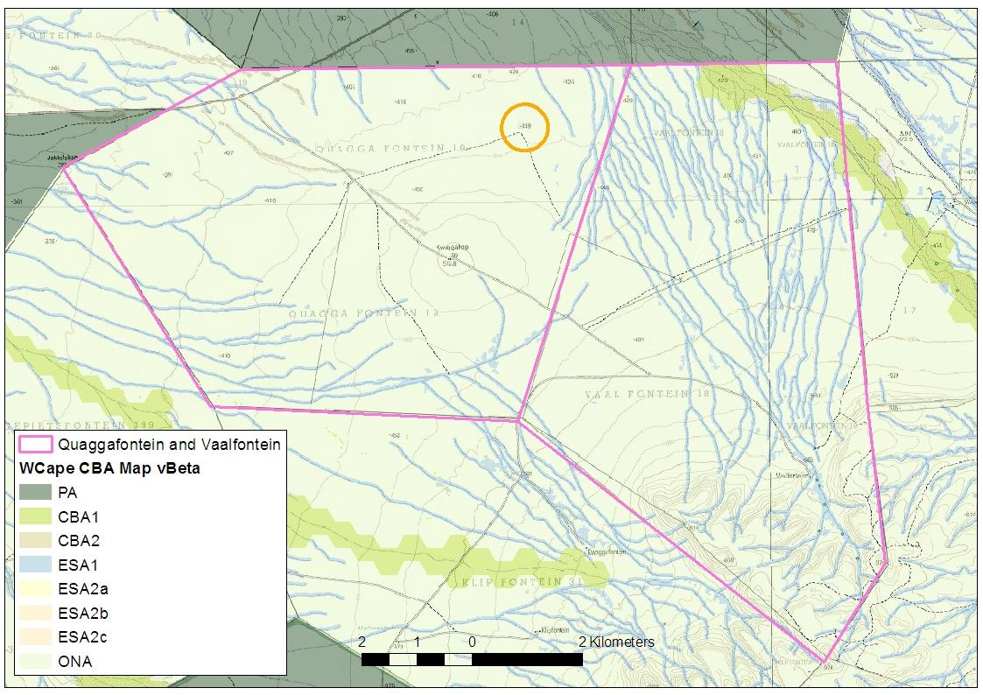
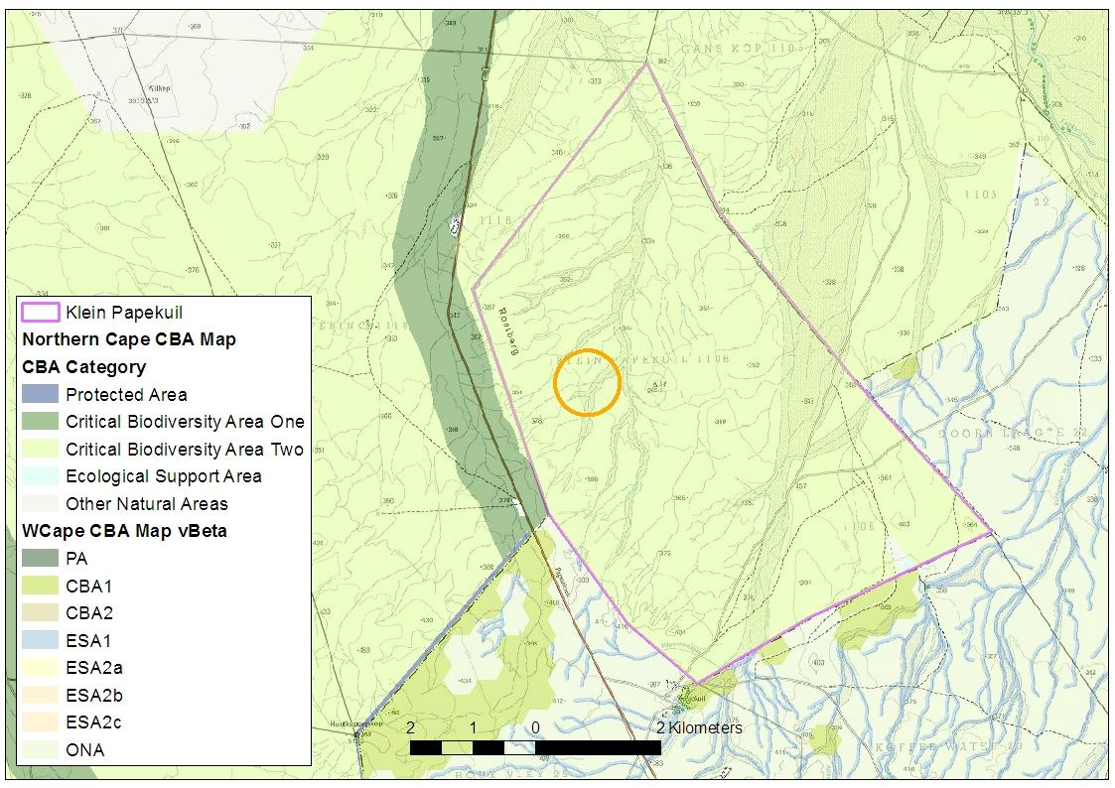
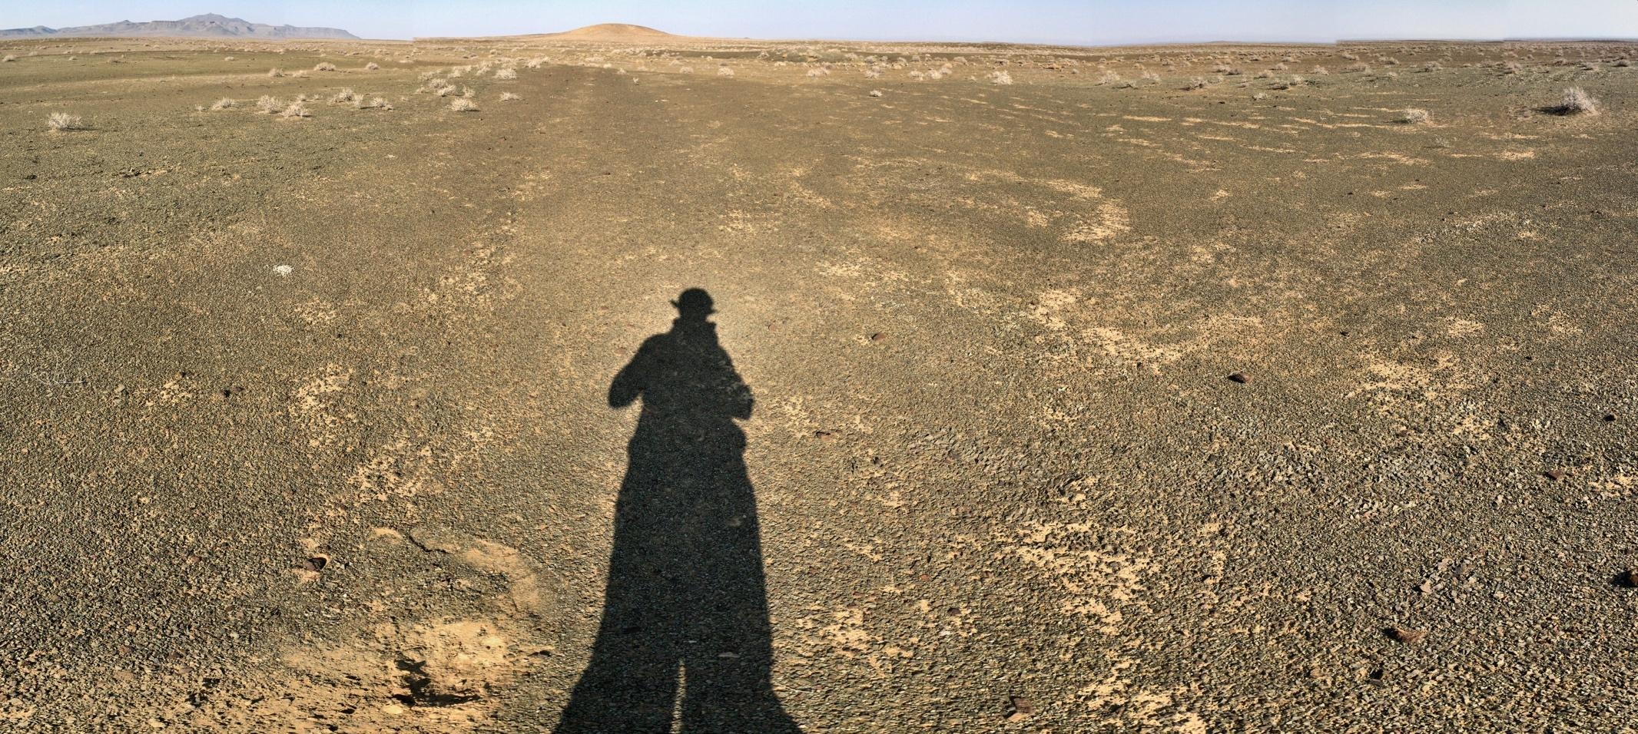
Figure 4. The plains around “Benny Hill” looking towards the south and Kwaggaskops (middle) and Skoorsteenberge (left).

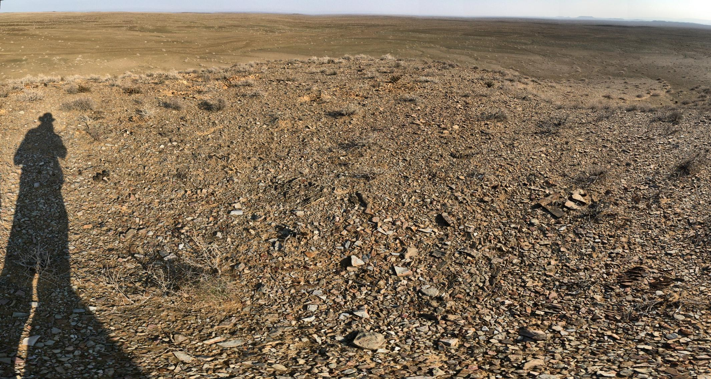
Figure 5. The view from the top of “Benny Hill” looking northwards towards the Tankwa National Park. The Roggeveld Escarpment is just visible on the right horizon.

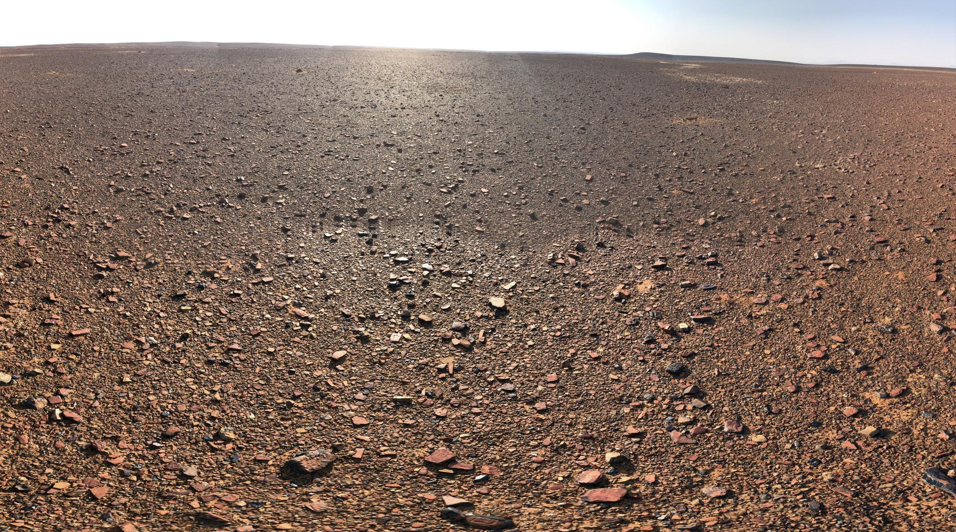
Figure 6. The Mars-like desert pavement landscape of Klein Papekuil looking north from the orange circle indicated in Figure 3.

